**WEEK-1**

**Week 1: Programming Assignment 1**

import java.util.Scanner;

public class Exercise1_1 {

public static void main(String[] args) {

Scanner s = new Scanner(System.in);

double radius= s.nextDouble();

double perimeter;

double area;

perimeter = 2 * Math.PI * radius;

area = Math.PI * radius * radius;

System.out.println("Perimeter is = " + perimeter);

System.out.println("Area is = " + area);

}

}

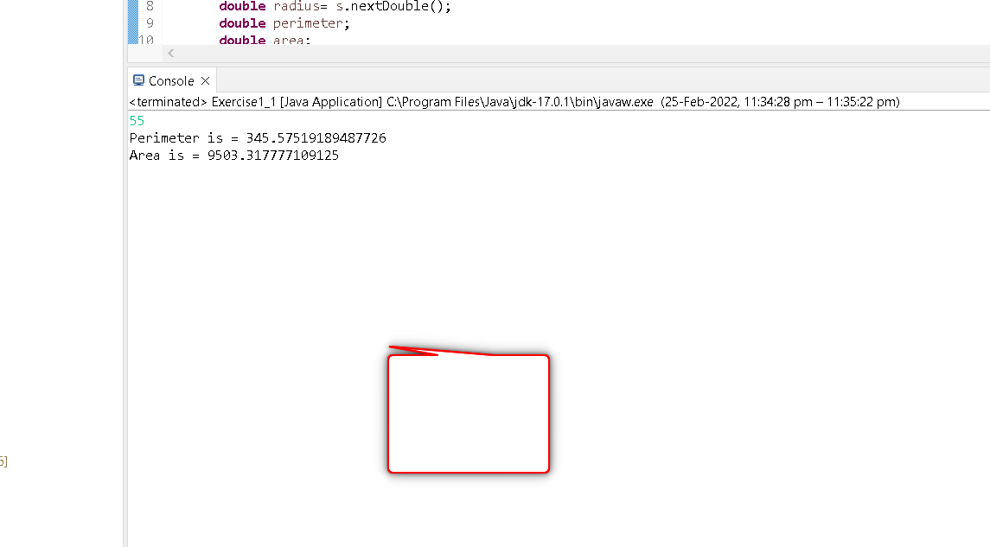

# Week 1 : Programming Assignment 2

package weeks;

import java.util.Scanner;

public class Exercise1_2 {

public static void main(String[] args) {

Scanner s = new Scanner(System.*in*);

int x = s.nextInt();

int y = s.nextInt();

int z = s.nextInt();

int result = 0;

//Use if...else ladder to find the largest among 3 numbers and store the largest number in a variable called result.

if(x >= y && x >= z)

{

result=x;

}

else if(y >= z)

{

result=y;

}

else

{

result=z;

}

System.*out*.println(result);

}

}

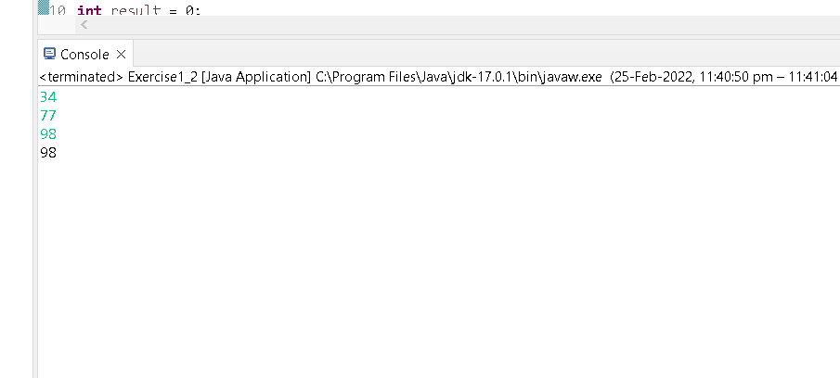

# Week 1 : Programming Assignment 3

import java.util.Scanner;

public class Exercise1_3 {

public static void main(String[] args) {

Scanner sc = new Scanner(System.in);

int n=sc.nextInt();

int sum=0;

int result=1;

int i=0;

while(result<=n)

{

if(i%2==0)

{

if(i%3==0)

{

sum=sum+i;

}

result=result+1;

}

i=i+1;

}

System.out.println(sum);

}

}

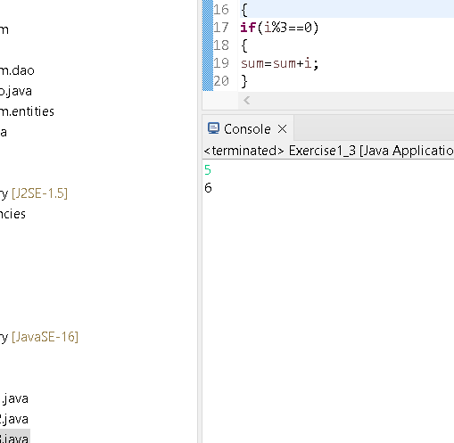

# Week 1 : Programming Assignment 4

import java.util.Scanner;

public class Exercise1_4 {

public static void main(String[] args) {

Scanner sc = new Scanner(System.in);

int n=sc.nextInt();

int result=0;

//Use while loop check the number is Armstrong or not.

//store the output(1 or 0) in result variable.

int temp=n;

int c=0,t;

//Use while loop to check the number is Armstrong or not.

while(n>0)

{

t=n%10;

n=n/10;

c=c+(t*t*t);

}

if(temp==c)

result=1;

else

result=0;

//Evaluation code

System.out.println(result);

}

}

0 = not armstrong number

1 = armstrong number

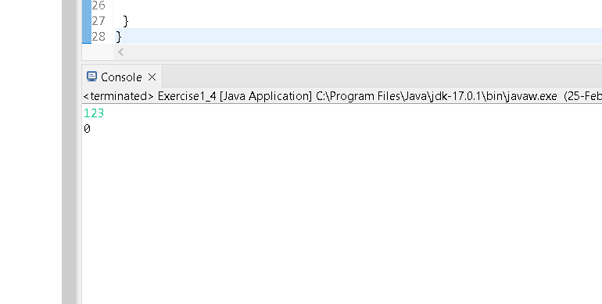

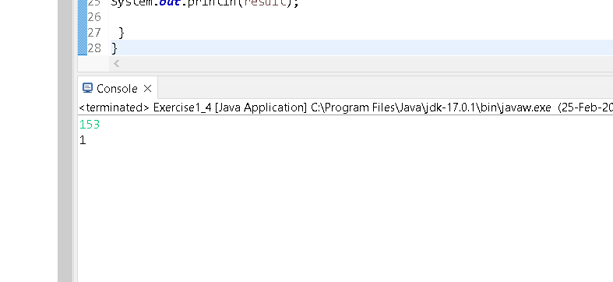

# Week 1 : Programming Assignment 5

package weeks;

import java.util.Scanner;

public class Exercise1_5{

public static void main(String[] args) {

Scanner input = new Scanner(System.*in*);

double mark_avg;

int result;

int i;

int s;

s = input.nextInt();

int[] arr = new int[s];

for(i=0;i<arr.length;i++)

{

arr[i]=input.nextInt();

}

int max=arr[0];

double sum=arr[0];

for(i=1;i<arr.length;i++)

{

sum=sum+arr[i];

if(arr[i]>max)

max =arr[i];

}

result=max;

mark_avg=sum/(arr.length);

System.*out*.println(result);

System.*out*.println(mark_avg);

}

}

# Week 2 : Programming Assignment 1

class School {

public void print() {

System.out.println("Hi! I class SCHOOL.");

}

}

class Student {

public void print() {

System.out.println("Hi! I am class STUDENT");

}

}public class Question21{

public static void main(String args[]){

Student student = new Student();

student.print();

School school = new School();

school.print();

}

}

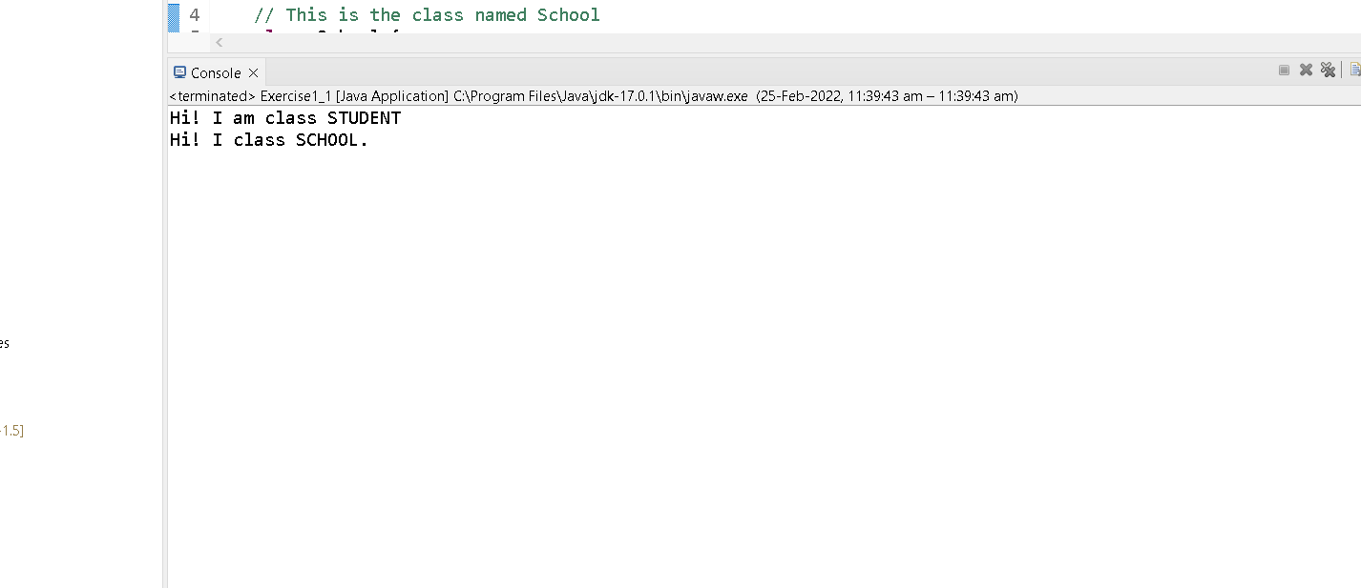

# Week 2 : Programming Assignment 3

package weeks;

//This is the main class Question

public class Question23{

public static void main(String[] args) {

// Object of the main class is created

Question23 q = new Question23();

// Print method on object of Question class is called

q.studentMethod();

}

// 'print()' method is defined in class Question

void print(Question23 object){

System.*out*.print("Well Done kaushal");

}

// 'studentMethod()' method is defined in class Question23

void studentMethod(){

// Calling a method named 'print()' in class Question23

print(this);

}

}

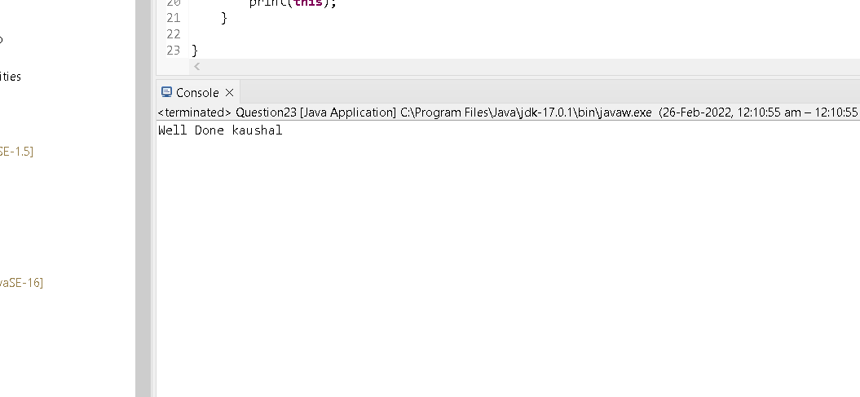

# Week 2 : Programming Assignment 4

package weeks;

//This is the main class Question

public class Question24{

public static void main(String[] args){

Answer a = new Answer(10,"MCQ");

}

}

//This is the class Answer

class Answer{

// This is the default constructor of the class Answer

Answer(){

System.*out*.println("You got nothing.");

}

// This is a parameterized constructor of the class Answer

Answer(int marks, String type){

//The 'this()' referene variable is able to call the default constructor of the class.

this();

//Print marks and type of the question

System.*out*.println("You got "+marks+" for an "+ type);

}

}

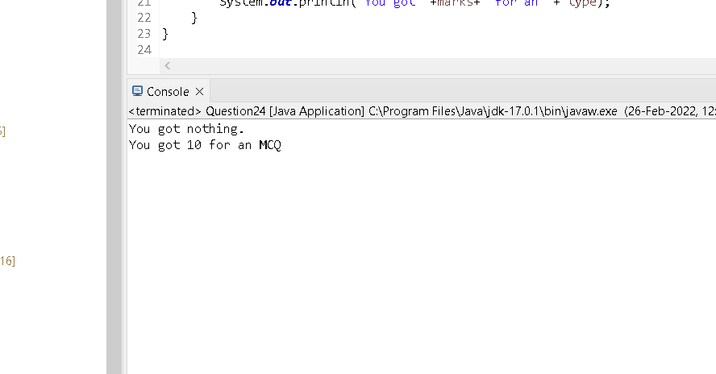

# Week 2 : Programming Assignment 5

public class Question214{

public static void main(String[] args){

Answer a = new Answer(10,"MCQ");

}

}

class Answer{

// This is the default constructor of the class Answer

Answer(){

System.out.println("NPTEL JAVA");

}

Answer(int marks, String type){

this();

System.out.println("NPTEL JAVA”);

}

}

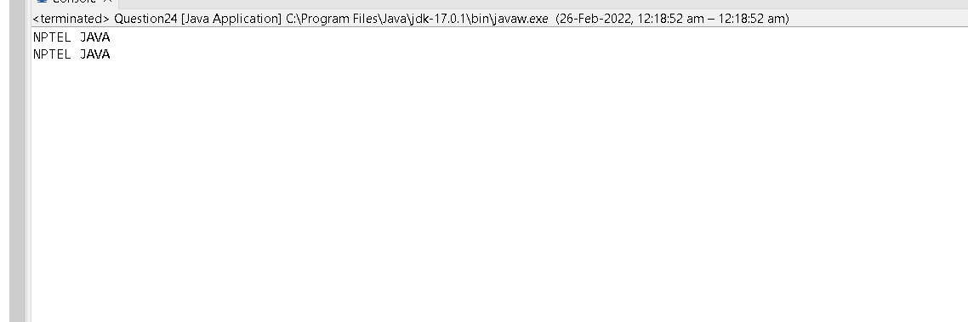

# Week 3 : Programming Assignment 1

package weeks;

import java.util.Scanner;

public class Fibonacci {

public static void main(String args[]){

Scanner sc = new Scanner(System.*in*);

int n=sc.nextInt();

System.*out*.println(*fib*(n));

}

//Template code:

static int fib(int n) {

if (n==1) //Terminal condition

return 0;

else if(n==2)

return 1;

return *fib*(n - 1) + *fib*(n - 2); //Recursive call of function

}

}

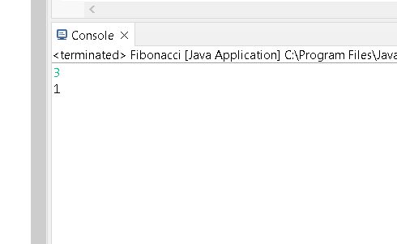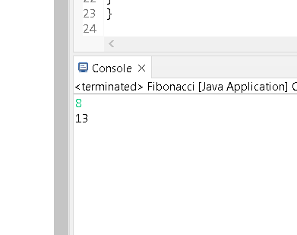

# Week 3 : Programming Assignment 2

package weeks;

import java.util.Scanner;

public class Circle extends Point{

public static void main(String[] args) {

Scanner sc = new Scanner(System.*in*);

Point p1=new Point();

p1.x=sc.nextDouble();

p1.y=sc.nextDouble();

Point p2=new Point();

p2.x=sc.nextDouble();

p2.y=sc.nextDouble();

Circle c1=new Circle();

c1.*distance*(p1,p2);

}

}

class Point{

double x;

double y;

public static void distance(Point p1,Point p2){

double d;

d=Math.*sqrt*((p2.x-p1.x)*(p2.x-p1.x) + (p2.y-p1.y)*(p2.y-p1.y));

System.*out*.println(d);

}

}

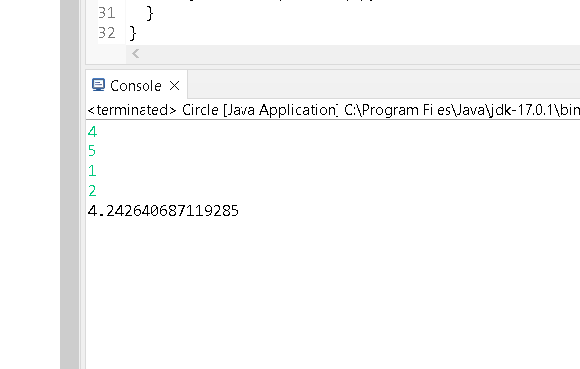

# Week 3 : Programming Assignment 3

package weeks;

import java.util.Scanner;

class Shape{

double length, breadth;

Shape(double l, double b){ //Constructor to initialize a Shape object

length = l;

breadth= b;

}

Shape(double len){ //Constructor to initialize another Shape object

length = breadth = len;

}

double calculate(){// To calculate the area of a shape object

return length * breadth ;

}

}

public class gttvbtu extends Shape{

//Template code:

double height;

gttvbtu(double length,double h) {

//base class constructor with one parameter is called

super(length);

height=h;

}

gttvbtu(double length,double breadth,double h) {

//base class constructor having two argument is called

super(length,breadth);

height=h;

}

double calculate() {

return length*breadth*height;

}

public static void main(String args[]){

Scanner sc = new Scanner(System.*in*);//Create an object to read

//input

double l=sc.nextDouble(); //Read length

double b=sc.nextDouble(); //Read breadth

double h=sc.nextDouble(); //Read height

gttvbtu myshape1 = new gttvbtu(l,h);

gttvbtu myshape2 = new gttvbtu(l,b,h);

double volume1;

double volume2;

volume1 = myshape1.calculate();

volume2=myshape2.calculate();

System.*out*.println(volume1);

System.*out*.println(volume2);

}

}

# Week 3 : Programming Assignment 4

package weeks;

import java.util.Scanner;

class QuestionScope {

int sum(int a, int b){ //non-static method

return a + b;

}

static int multiply(int a, int b){ //static method

return a * b;

}

public static void main( String[] args ) {

Scanner sc = new Scanner(System.*in*);

int n1=sc.nextInt();

int n2=sc.nextInt();

QuestionScope st = new QuestionScope(); // Create an object to call non-

//static method

int result1=st.sum(n1,n2); // Call the method

int result2=QuestionScope.*multiply*(n1,n2); // Create an object to call

//static method

System.*out*.println(result1);

System.*out*.println(result2);

}

}

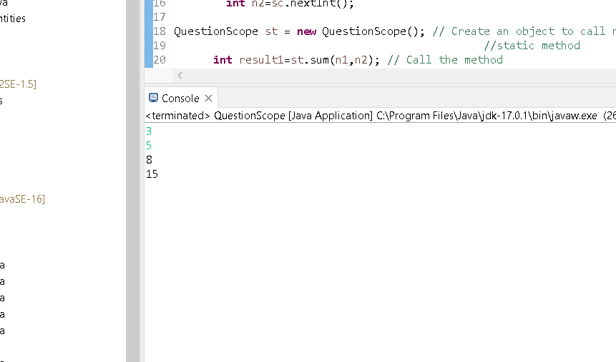

# Week 3 : Programming Assignment 5

package weeks;

import java.util.Scanner;

class Question { //Define a class Question with two elements e1 and e2.

Scanner sc = new Scanner(System.*in*);

int e1 = sc.nextInt(); //Read e1

int e2 = sc.nextInt(); //Read e2

//Template code

//Define static method swap()to swap the values of e1 and e2 of class T.

public static void swap(Question t) {

int temp = t.e1;

t.e1 = t.e2;

t.e2 = temp;

}

public static void main(String[] args) {

//Create an object of class Question

Question t = new Question ();

//Call the method swap()

*swap*(t);

System.*out*.println(t.e1+" "+t.e2);

}

}

